
Capstone Project: UK Train Rides
Week No: W15

1. Team Name: Elite Team

2. Selected Project: Project Idea 6: (Outstanding): UK Train Rides.
3. Team Leader: Ahmed Hussein Ali Mustafa

The group:
No. | Full Name in English | Full Name in Arabic | Student ID | Education Background | Governorate
1 | Ahmed Hussein Ali Mustafa | أحمد حسين علي مصطفى | 21090350 | MBA + Bachelor of commerce in accounting | Suez
2 | Fatma Alzahraa Galal Abd-elsalam Soliman | فاطمه الزهراء جلال عبد السلام | 21090461 | Bachelor of Pharmacy | New Valley
3 | Heba Tallah Talaat Ezzat Ibrahim | هبه الله طلعت عزت ابراهيم | 21077992 | Master's degree in science + bachelor’s degree in science | Suez
4 | Kareman Mohamed Mahmoud Awad | كاريمان محمد محمود عوض | 21090780 | Bachelor of Engineering | Gharbia
Tools Selected
You need to select three different tools at least: Excel, Power BI, Tableau, Python, SQL

Answer: Excel, Power Bi, Tableau and SQL.

- Data cleaning and transformation
- Data modeling, analysis
- Data visualization
- Dashboard creation

Business Questions:
- Operational Efficiency:
  - What is the overall on-time performance of train journeys?
  - How many journeys were delayed, and what were the reasons? And determine the effect on refund requests ?
  - How many journeys were cancelled? What is its percentage ?
  - What are the peak travel times and most popular departure stations?
  - What is the relationship between weather conditions and train punctuality? Or What is the effect of weather conditions on all train journeys?

- Financial Analysis:
  - What is the total revenue generated from ticket sales?
  - Which ticket class (Standard, First Class) generates the most revenue?
  - What are the most common train routes based on ticket sales?
  - How do different payment methods correlate with ticket purchases?
  - What are the peak hours for train travel, and how do they impact revenue?
- Customer Behavior:
  - What are the most crowded departure and arrival stations?
  - Which railway lines have the highest passenger demand based on ticket sales?
  - What is the distribution of ticket types (Advance, Off-Peak, Anytime) purchased?
  - How does the purchase time affect ticket prices?
- Demographic Insights:
  - What is the distribution of rail card types (Adult, Senior, Disabled, etc.) used?
  - Which payment methods are most commonly used?

- Route Analysis:
  - Which routes are the most frequently traveled?
  - What is the average journey duration for different routes?
  - Are there any routes with consistently high delays?

Mockups

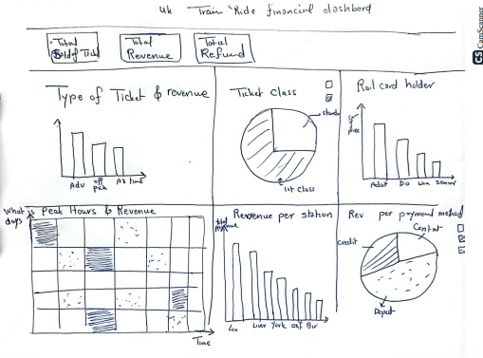
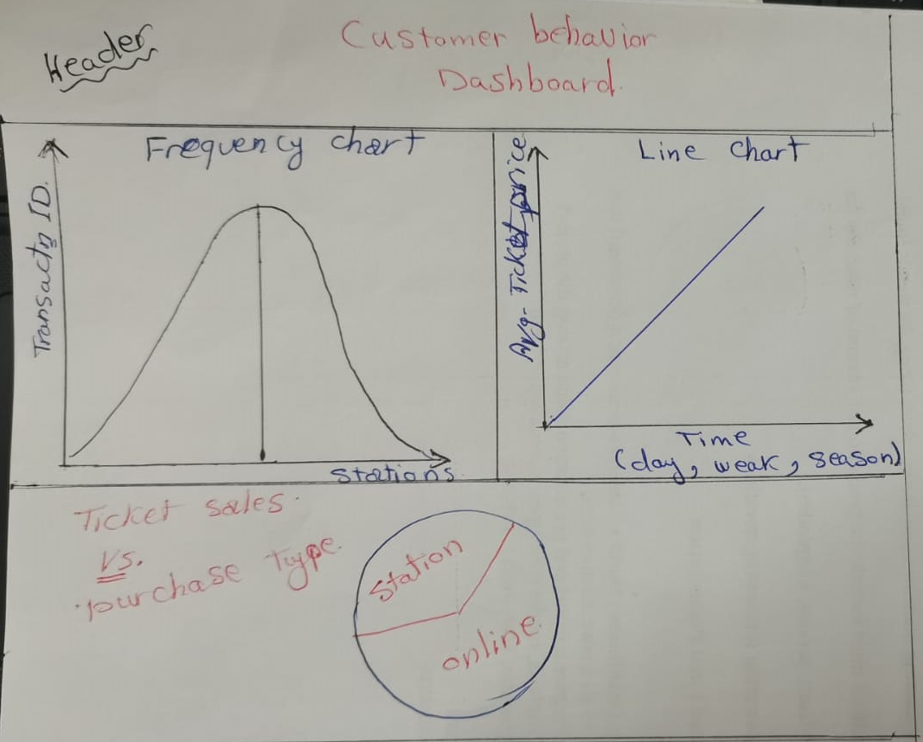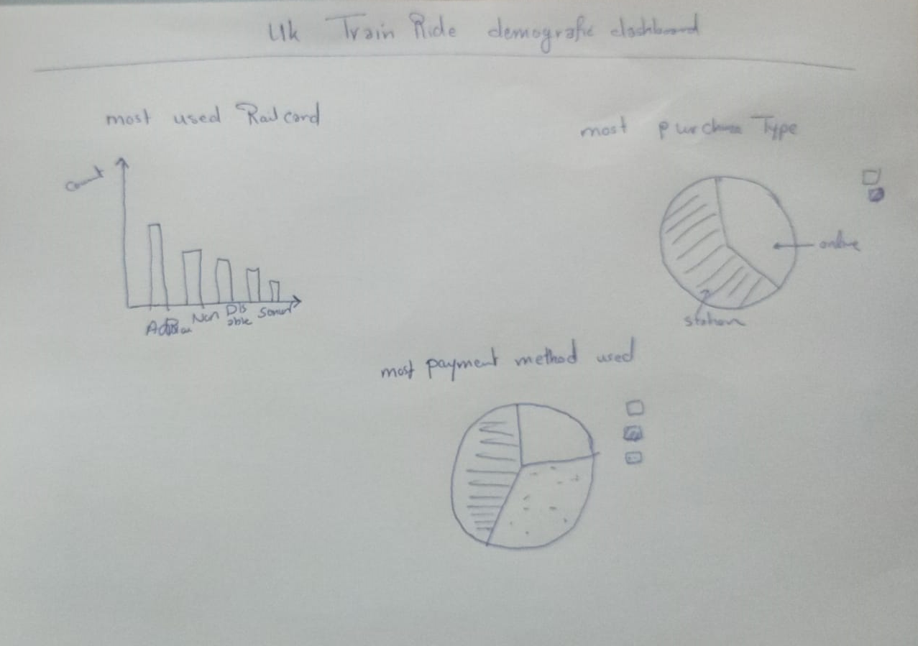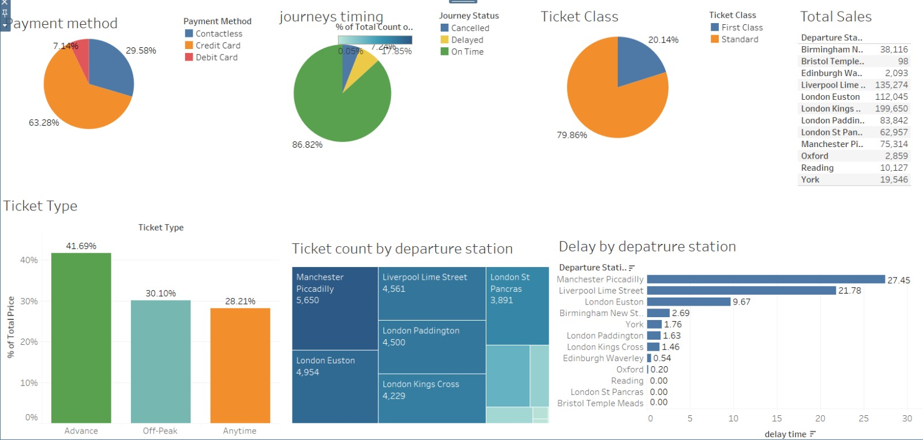



The Analytical dashboard comes with 4 different tabs each
considering a separate field to analyze.

Sample of charts

